Shabbos Stories For
Parshas noach 5787
Volume 18, Issue 5 6 Cheshvan/October 17, 2026
Printed L’illuy nishmas Nechama bas R’ Noach, a”h

The Scrap Paper “Airplane”
By Yoni Schwartz

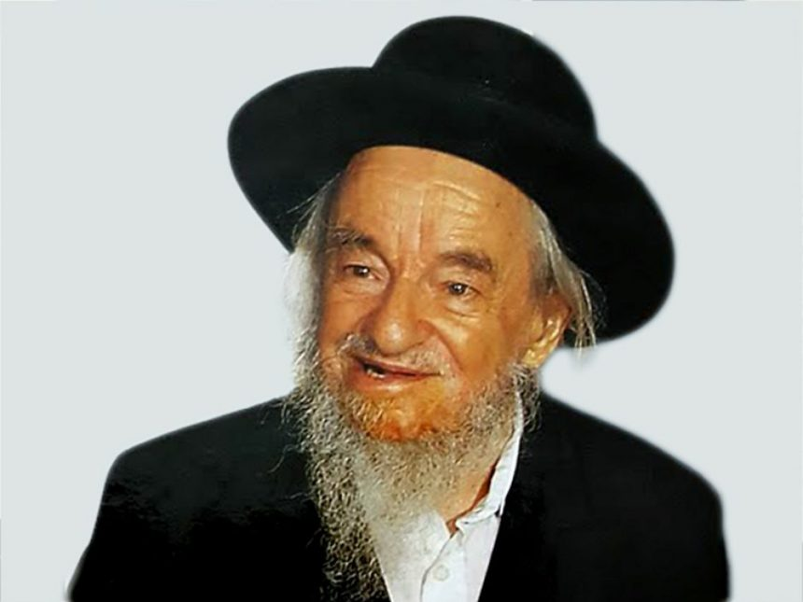

Rav Yaakov Galinsky, ZT”L, had a son who was an incredible genius, Rav Nachman Galinsky. Unfortunately, he got sick and passed away all too soon. When his family was sitting shiva, a man whom they did not recognize walked in and sat down.
When they asked him how he knew Rav Nachman, he replied with the following story: “Now I am a Rosh Yeshiva myself and have hundreds of talmidim who learn under me. However, when I was young, in middle school, I struggled with learning.
“One hot day, I decided to make a state-of-the-art F-16 airplane from a piece of scrap paper. When my piece of art was finally complete, I threw it over to my friend who was sitting nearby, whom I knew was also not paying attention during shiur. I did not realize, however, that the fan was blowing strongly, and when I threw it, the jet rerouted its course and headed into a danger zone. It landed on the Rosh Yeshiva’s desk, on his Gemara, while he was in the middle of giving a shiur.
Immediately, he stopped, banged on the table, and said, ‘I’m not continuing until whoever threw that airplane gets up and leaves the classroom.’ I was already on thin ice with the yeshiva, and that would have been the straw that broke the camel’s back. I simply could not risk getting kicked out of yeshiva.
Suddenly, Rav Nachman stood up and walked out. Everyone knew, including the Rosh Yeshiva, that he didn’t throw that airplane. He was a star student. However, the Rebbe was forced to continue his shiur. After that scare, I decided to start taking things seriously in my learning and found tremendous success. Rav Nachman changed my life.’”

Reprinted from the Rosh Hashanah 5786 email of Torah Sweets.

The “Lost” Wallet

One day, a woman arrived home and discovered that her wallet was missing. She had left the house with more than 600 shekel, spent some in Yerushalayim, and loaded 100 shekels onto her bus card, leaving about 400 shekels in the wallet. She assumed she had left it on the bus, but the bus company had no record of finding it.
With no identifying cards inside, she feared it was gone, but she refused to give up hope, stating that she would give the finder ten percent of the cash. She decided to view the loss as a kapparah.
Meanwhile, a young man waiting for his bus noticed a wallet wedged beside the bench. Inside were 400 shekel but no obvious identification. Then he spotted the receipt for the bus-card reload. Seeing it as a possible lead, he called the bus company and, with the help of an unusually cooperative operator, obtained the owner’s name and phone number.
He called the family, explained how he had found them, and insisted on bringing the wallet to their home in Beitar himself so he could fulfill the mitzvah of hashavas aveidah in the best possible way. When he arrived, the husband offered him the promised ten percent, but he refused. “I don’t need the money. I need a brocha.”
He explained that although he was no longer young, he had not given up his dream of finding a wife who would enable him to devote his life to learning Torah. As the husband gave him a brocha, his wife suddenly remembered Nechama, who had once spent Shabbos with them and had confided that she was still hoping to find a husband who would be devoted to learning Torah.
The connection seemed almost too perfect to ignore, and the family became shadchanim. Calls and inquiries followed, and eventually the two were introduced and a shidduch was made. At the vort, the young man laughed, “I only wanted to return a lost object—and in return, I found mine.” (Meant To Be)

Reprinted from the 5787 email of The Weekly Vort.

The Unusual Miser
By Nissan Mindel

In the city of Berditchev a very wealthy man, regarded by all as a miser, died. When famed Rabbi Levi Yitzchok of Berditchev heard of the man's passing, he was grieved and said he would attend the funeral.
When the news spread that Reb Levi Yitzchok would come, never was there such a crowd as attended the funeral of this richman. Yet, no one could understand why Reb Levi Yitzchok was showing so much respect for the dead miser.
After the funeral, Reb Levi Yitzchok said, "Nobody really knew this man as I did. He had a noble character that I discovered through three separate incidents when he came to me." And he told the following stories:
A wine merchant who acted as agent for other merchants was going on his usual purchasing trip when he suddenly discovered that his money was missing. When he realized his terrible situation, he fainted. A doctor was called and managed to revive him. But, as soon as the agent regained consciousness and remembered his great loss, he fell into another swoon. A Jew suddenly stepped forward from the crowd and declared that he had found the missing bag of money. Everyone was delighted and the agent revived miraculously!
"Some time later," related Reb Levi Yitzchok, "two Jews came to see me. One was the man who was just buried. The second Jew claimed that he, in fact, had found the wine agent's money but could not resist the temptation to keep it. However, when he found out that someone had given away such a large sum of money in order to save a man's life, his conscience troubled him. He had repented and was now eager to repay the money.
But the first man (whose funeral was just held) refused to accept the money, saying he did not want to give up the mitzva of saving the agent's life.
"And my verdict," said Reb Levi Yitzchok, "was that he wasnot obliged to accept the money if he did not wish to. The man who had repented would have to find some other way of making amends."
There was a Jew who was unsuccessful in business and could not support his family. He decided that he would go away to try his luck somewhere else. He told his wife that this same rich man had engaged him to do business in a certain city and that she should go to collect part of his salary each Thursday at the rich man's place of business. The wife didn't know that this "arrangement" was her husband's invention.
On the first Thursday she presented herself at the office and demanded her husband's salary. The rich man overheard her conversation with his secretary and said, "She is quite right. Pay her the money each Thursday. Sorry, I forgot to tell you about this arrangement sooner."
Time passed and when the husband returned home, after having been very successful, he found that his wife had managed well on the "salary" she drew every week. With that, the husband went off to see the rich man, thanked him for his good-heartedness and tried to repay him. But the rich man would not hear of it.
The case was brought before Reb Levi Yitzchok. "My verdict was that the husband could not compel the rich man to accept the money."
A certain man in great financial difficulties came to this rich man and asked for a loan. "Who will be your guarantor in case you cannot repay the loan?" he asked. The only guarantor I can offer you is the Alm-ghty" he answered.
"Very good," said the rich man. "You could not have chosen a more reliable guarantor."
Sometime later, the man came to return the money he had borrowed.
"Your Guarantor repaid me the loan through an unexpected profit," said the rich man. "So, you see, you don't owe me anything."
The grateful Jew insisted that the case be brought before me," said Reb Levi Yitzchok. "This time, too, I said that the rich man could not be compelled to accept money which he did not want."
"So, you see, my friends," concluded Reb Levi Yitzchok, "that the deceased was not mean or miserly. He just preferred giving charity anonymously. And that way of giving charity is the highest form of charity-giving. The man who has just been buried was truly a great, saintly Jew."

Reprinted from the Parasha 5785 edition of L’Chayim. Excerpted from the book – “The Storyteller.”
The Pipes Unclogged
By Rabbi Moshe Hirschberg

When Mrs. Braun* and her husband opened a printing company in Central New Jersey, they were confident they were entering a thriving industry. Printing was in constant demand, and they were certain the business would quickly take off.
It didn’t.
Customers came only sporadically. Month after month, the bills piled up while the loans they had taken to launch the business remained unpaid. A year and a half after opening their doors, they had little to show for all their effort besides mounting debt and growing anxiety.
One evening, as Mrs. Braun sat down to supper, an unexpected thought entered her mind.
More than twenty years earlier, a close friend had hurt her deeply. Although the years had passed, the pain had never truly faded. She had carried that resentment with her ever since.

At that moment, she made a decision. As a zechus for parnassah, she would let it go.
It wasn’t easy. Every emotion urged her to leave the past buried where it was. But she refused to listen to those feelings. She picked up the phone, called her former friend, and told her sincerely that she forgave her b’lev shalem, full-heartedly. The conversation ended.
About an hour later, the phone rang. It was a businessman whom her husband had approached more than a year earlier about investing in the company. “I’ve been thinking,” he said. “And I’ve decided to move forward.” After a brief discussion, he committed to investing $130,000.
He was the first investor who agreed to put in a substantial amount into the corporation. This would give some leeway for the business to form and grow.
But the story doesn’t end here.
Before they even had time to absorb the news, the phone rang a second time. It was Mr. Braun’s brother-in-law. “I know things have been difficult,” he said. “I’d like to help.” He sent them another $100,000.
In the span of just two hours, more than $230,000 came their way, rescuing the business from the financial quicksand it had been trapped in for so long. That gave them flexibility to extend the business and bring in a supervisor who not only covered his salary but also brought in new clients that made the entire corporation fruitful.
Sometimes the greatest obstacle to brachah is not outside of us, but within us. Once Mrs. Braun found the strength to release a decades-old grievance, it was as though the channels that had been holding back her parnassah suddenly opened. The blockage was gone, and the flow began.

Reprinted from Issue #273 of Zichru Moshe Toras.

Rav Chaim’s Advice

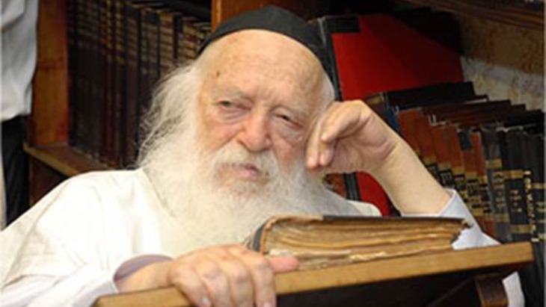

It was Rosh Hashanah morning, and a solemn, quiet hum filled the study of Maran HaGaon R’ Chaim Kanievsky zt”l. Because space was severely limited in his home, every seat allocated beyond the immediate family carried deep weight and not just anyone could enter.
Among the small gathering of mispallelim, one man stood out. There was an intense, unmistakable posture to his davening, an aura of profound devotion that immediately drew the eyes of those around him. Seeking to understand who this man was and how he had come to claim such a coveted place in R’ Chaim’s inner sanctum, a grandson approached him after davening.
When asked about his background, the man smiled, a look of someone who had carried a secret for years, simply waiting for the right moment to share it. He explained that his journey had begun thirty years earlier, born out of a catastrophic car accident that had completely crushed his leg. In the painful years following the crash, his life had been defined by immobility and despair.
The most elite medical minds had carefully examined his file, evaluated the terrifying X-rays, and delivered a unanimous, shattering verdict: the damage was far too extensive, and the chances of restoring any function were absolute zero. No doctor was willing to take the risk of operating on a leg so thoroughly shattered. On one occasion, a specialist had scheduled a date for surgery, only to get cold feet the evening before and cancel the procedure entirely. Left with a ruined leg and dim prospects, the man was forced to accept a life of physical limitation. Eventually, seeking spiritual solace, he entered the humble residence of R’ Chaim Kanievsky. He poured out his broken heart, explaining that he could barely walk and that no doctor on earth would risk operating on his leg.
R’ Chaim listened, but rather than focusing on the medical impossibility, he asked a single unexpected question: “Are you able to do Korim?” (In Mussaf on Rosh Hashanah and Yom Kippur, during Aleinu and the avodah, every person kneels - on the ground.) The man shook his head sadly, explaining that he could barely stand on his foot, let alone bend down to kneel.
Without hesitation, R’ Chaim looked at him with absolute certainty and commanded: “Perform the operation so that you can kneel!” When the man tried to protest, repeating the definitive judgments of the world’s leading orthopedic surgeons who insisted the leg was beyond repair, the Sage refused to hear another word. He simply repeated the directive with unwavering conviction: go perform the surgery so that you can do Korim before the King.
Well, armed with this clear spiritual mandate, the man felt a surge of renewed strength. He sought out the top orthopedic specialist in the world, a non-Jewish doctor renowned for handling the most impossible cases. Moved by the patient’s relentless determination, the doctor surprisingly agreed to re-examine the file and, against all medical precedent, decided to take on the high-risk operation.
The surgery stretched on for agonizing hours, every movement fraught with peril. Yet, against all physical odds, the operation was a breathtaking success. For the first time in three decades, after months of grueling rehabilitation, the man was able to lower himself to the ground, bend his knee, and pour out his soul in tearful gratitude to the Almighty.
Overwhelmed by what had transpired, the man traveled to thank the world-famous surgeon who had performed the medical marvel. But as he began to express his deep gratitude, the non-Jewish doctor abruptly cut him off, raising his hands in protest.
“You have nothing to thank me for!” the surgeon exclaimed his voice filled with genuine awe. “You must thank only the Creator, the Blessed One! I have performed thousands of complex surgeries in my career, but I have never in my life attempted a procedure so complicated. Science cannot explain how your leg was restored. It was only a direct hand from Above - pure Divine assistance - that carried you through that operating room and put you back on your feet.”
Standing in the quiet atmosphere of R’ Chaim’s study, the venerable Jew concluded his extraordinary tale. It was not merely medicine that had healed his body, but the beracha of a holy tzaddik who saw past human limitations. Since his miraculous recovery, he made it his sacred mission to return year after year, traveling to do Korim on Rosh Hashanah in the shadow of R’ Chaim Kanievsky, eager to bow, kneel, and surrender his heart in the very place where his miracle was born.

Reprinted from the Rosh Hashanah 5787 email of Rabbi Dovid Hoffman’s Torah Tavlin.

The Power of a “Niggun”

Reb Yisrael Dov Ber was a chasid of the Maharash (Lubavitch). He was a man of warmth who had an inner fire that was evident in his avodas ha’kodesh, every aspect of his holy service to the Almighty. Even the brightest flame can flicker, however, and Reb Yisroel Dov Ber could not determine why his tefillos lacked their usual passion.
Davening was the benchmark of his day, and, if he did not daven well, his day (in his opinion) lacked meaning. When a good chasid has a problem he turns to his Rebbe-which he did. “Rebbe!” he cried, “Ich bin gefallen.” (I have fallen [had a spiritual decline].)
The Rebbe looked at him with the gentle eyes of a father looking at his child, and he said “Sing!”
“Rebbe, what song can I sing? I am lost. I have lost my bren, fire.”
The Rebbe repeated himself, “Sing a niggun, song.”
Reb Yisrael Dov Ber began to sing — not only from his lips, but also from the inner recesses of his heart and soul. As he sang, tears flowed from his eyes. These were not tears of despair, but tears heralding his “return.”
He had not fallen; he had forgotten where he belonged. We all go through such moments in life when we forget where we belong. A sort of spiritual slump overtakes us. Our neshamah never forgets. Its directional signal is always focused. All it needs is the song from the heart to engage it and put us back on track

Reprinted from the Parshas Ha’azinu 5786 edition of Peninim on the Torah as edited by Rabbi L. Scheinbaum.

A Divided Family

David Rosen was raised in an assimilated Jewish home where Judaism was nothing more than a mere cultural memory-not a living heritage with a meaningful and purposeful destiny. David was a bright student with a promising future, but with little to no meaning in his life.
He visited a Chabad house on campus for a Friday night meal, and something within him stirred. A spark was waiting to be ignited and stoked into a passionate flame. He returned often, during which his inspiration motivated him to observe Shabbos, don Tefillin, keep kosher dietary laws, until he became fully observant, having embraced all the mitzvos.
His family thought that he had become unhinged. His friends ridiculed him. He did not care, because he answered to a Higher Authority. While he loved his parents, he could not ignore that his spiritual life had taken a different trajectory than theirs. Their relationship was respectful, but reserved, until David's father was diagnosed with a terminal disease.
David no longer was just a son visiting his dad, but a beacon of light and hope during his months of pain and fear of this dread disease. He sat by his father’s bed, reciting Tehillim, watching the chemicals dripping into his father’s veins. He spoke of hope, faith, and love for Hashem. During those final weeks of his father’s life, David engendered hope and dignity.
Then, something unbelievable and totally unexpected occurred. David’s father asked him to help him put on Tefillin. He knew that he could not change his past, but if he could somehow infuse his future, albeit short, with meaning, he would try. They prayed together daily until his father passed away with Shema Yisrael as his final words. David’s mother and sister were moved by the transformation, and the religion that they had so erroneously shunned became a beacon of light and hope to them. The entire family became observant, because David refused to allow the status quo of his upbringing to define his future-his acharis.

Reprinted from the Parshas Ha’azinu 5786 edition of Peninim on the Torah as edited by Rabbi L. Scheinbaum.

Rabbi Shach and Boy Who Didn’t Understand the Gemara
By Yoni Schwartz

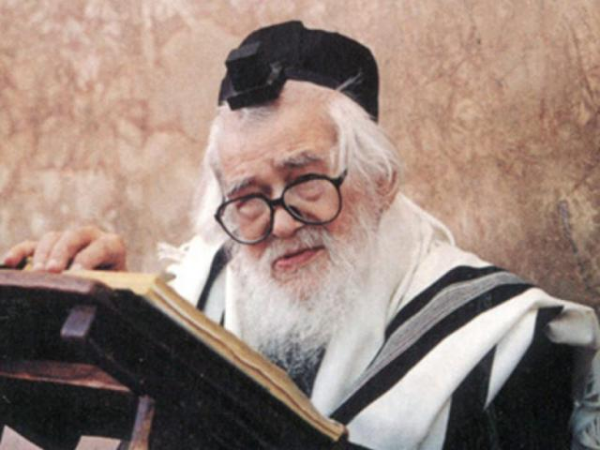

Years ago, many people gathered outside the apartment of Rabbi Elazar Shach, ZT”L, having come from across the country to discuss important matters with him. While Rav Shach was learning in his study before the meeting, a young boy somehow slipped past everyone and ran into his room.
“Rebbe! I have no geshmak (excitement) in my learning. I learn all day and try as hard as I can, but I just don’t grasp what’s going on. What should I do?” he asked.
Rav Shach told him to sit and asked which masechta he was learning.
“Bava Metzia,” the boy answered. Rav Shach took out two Gemaras and began learning with him. After going through the sugya once, Rav Shach asked, “Do you understand?”
The boy said no. “Let’s go through it again,” Rav Shach said, and they learned it again. Fifteen, thirty, forty-five minutes went by, and everyone outside was growing increasingly impatient.
After their third round of going through the Gemara, the boy suddenly exclaimed with tears rolling down his cheeks, “Rebbe, I understand!” He jumped with his face glowing and ran out smiling.
Later, Rav Shach’s assistant asked why he had delayed such important meetings to tutor one boy. Rav Shach replied, “This wasn’t just about understanding a sugya. It was about his relationship with Torah. Someone who doesn’t find a geshmak in learning Torah will look for it in other places. This was about the boy’s entire future.”

Reprinted from the Sukkos 5787 email of Torah Sweets

Speaking Against Oneself

Several years ago, one of the Gedolei Hador attended a wedding at the Paradise Hotel in Be’er Sheva, where he served as mesader kiddushin. After the chuppah, as he was walking toward the car, a thirty-five-year-old woman from Ofakim approached him in tears.
“Ever since I finished seminary, sixteen years ago, I have been searching for my zivug, but to no avail. The kallah who just got married was a girl I taught in preschool when I was twenty. She was only four years old. Sixteen years have passed, and she has merited to meet a wonderful ben Torah, while I still haven’t found my zivug.”
The Gadol felt tremendous compassion for her, but then asked an unusual question: “Have you ever cursed yourself? Have you ever spoken against yourself?” She thought for a moment.
“Yes. Fifteen years ago, when I was twenty and had just started going out, my father suggested a boy. He was a good boy, but I had concerns about the family and refused to meet him. My father insisted, and when I became angry, I told him, ‘If you force me to meet this boy, I will never get married.’”
The Gadol was shaken. “Really? That’s what you said?”
“Yes.”
He explained, “The Creator of the world has made a covenant with man’s lips. Our words have an impact and can even cause harm. We must rectify this.” He brought her to a local kollel, gathered three men, and had her stand in the center to conduct hataras nedarim.
“Now,” the tzaddik told her, “daven for your zivug. The same words that prevented you from finding your zivug will now become the words with which you daven and implore Hashem to grant you your chosson.”
She poured out her heart to Hashem, crying, “Hashem, You know how old I am. With every year that passes, the pain increases, along with the fear that soon my chance to marry and have children will be gone. Only You can save me.”
From that day on, she davened every day with tears, begging for a yeshuah. Six weeks later, she returned with an invitation to her vort, which was being held at the same Paradise Hotel. “I met an amazing man from South America. He is thirty-eight, and we’re getting married. Hodu laHashem!”
Four hundred people attended the vort, including the Gadol. With the kallah’s permission, he told them the story that had begun at that very spot just six weeks earlier. “I am certain,” he concluded, “that over the years, her family and friends suggested all kinds of possible solutions. Perhaps you need to lose weight. Perhaps it’s your glasses. Maybe you need to change the way you dress. Perhaps you’re too picky. But Hashem showed us that what was holding things back was something she had said fifteen years earlier.”
We don’t always understand the reason we are facing a particular challenge. Often, the reason is not at all what we might suspect. (Meant To Be)

Reprinted from the Succos 5787 email of The Weekly Vort.

True Simchas Ha’Torah
By Rabbi Shimon Finkelman
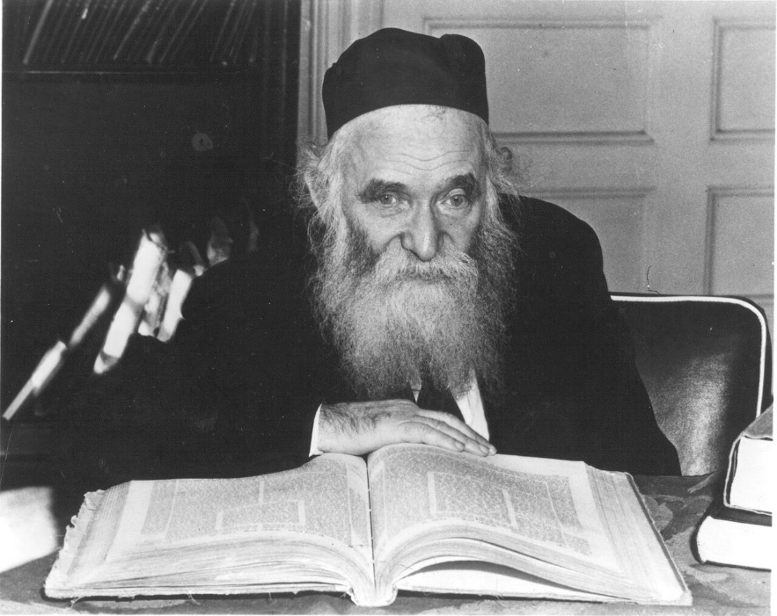

Aryeh, a talmid in Lakewood, once passed the office of R’ Aharon Kotler, and saw him dancing—all alone! He watched in amazement until R’ Aharon noticed him and asked him to call Boruch, one of the yeshivah’s outstanding talmidim, to the office. R’ Aharon spoke privately with Boruch for some time. Afterwards, Aryeh asked Boruch why the Rosh Yeshivah had summoned him. Boruch explained, “For more than twenty years, the Rosh Yeshivah has strained himself to understand a comment of the Vilna Gaon on Choshen Mishpat. Today, he finally arrived at what he is certain is the correct explanation. That is why the Rosh Yeshivah danced. He summoned me to share the explanation he had been me’chadesh.” (Excerpted from the book – “For Love of Torah”)

Reprinted from the Succos 5787 email of The Weekly Vort.
Wartime Chavruros


The Gerrer Rebbe – R’ Pinchos Menachem Alter

It was the second day of the Six-Day war. Bombs were falling everywhere. The sound of missiles hurtling through the air, the piercing wails of air raid sirens coupled with the tremendous, resounding “boom” as the bombs exploded on the streets of Yerushalayim, sowed fear and trepidation among the masses.
R’ Pinchos Menachem Alter zt”l, the young Rosh Yeshivah of Sfas Emes (future Gerrer Rebbe), huddled together with his Rebbetzin and young children in the air-raid shelter on the bottom floor of Yeshivas Sfas Emes.
Suddenly, there was a lull in the bombing and the Rosh Yeshivah couldn’t believe what he was hearing. The sweet sounds of kol Torah began to waft down into the shelter from the nearby beis medrash of Yeshivas Sfas Emes. Two chavrusos were learning. Who could be learning at a time like this, when all were cowering in bomb shelters in terror?
It was two elderly chassidim, Reb Leibel Lichtenstein and Reb Meir Gershon Sharetzky. They had a daily seder in the early, pre-dawn hours of the morning and they weren’t about to let bombs falling in the area disrupt it.
The Pnei Menachem became very emotional upon seeing this love of Torah and devotion to learning, and although he virtually never spoke about himself, at that moment he shared with his children a story that he had experienced in his own life. The story transpired just a few weeks after his bar mitzvah, following the outbreak of World War II.

The Warsaw Story
The young bachur, Pinchos Menachem, was in Warsaw as the Nazi blitzkrieg began strafing the beleaguered city with wave after wave of bombs. Within days, they had conquered Warsaw and had begun to terrorize the Jewish residents of the city, beating them, randomly shooting them, and snatching them off the streets to force them into dehumanizing slave labor.
Young Pinchos Menachem, however, had a seder with one of his cousins. It was a kevius (time set aside for learning) that he wasn’t ready to give up. Despite the desperate conditions outside, he surreptitiously made his way through the alleyways of Nazi-occupied Warsaw to the home of his chavrusa.
To his misfortune, a Nazi noticed the young Jewish lad and grabbed him off the street, throwing him into a truck that was transporting Jews to slave labor. As the truck filled up with other ill-fated Jews who had been caught, a Gerrer chasid who was passing by noticed, to his horror, that the ben zekunim (youngest son) of the Rebbe was on the truck!
He hid in waiting and, as soon as the saw the guards had somewhat slacked off in their duty, he motioned to Pinchos Menachem to slip away and follow him. He thereby saved the Rebbe’s son from terrible torture or death. The Pnei Menachem remembered this story and how the koach haTorah had protected him at that terrible time.

Reprinted from the Chag HaSukkos 5787 email of Rabbi Dovid Hoffman’s Torah Tavlin.

